TASK | Contact adhesive for gluing materials together
LOCATION OF USE | Workshop |  | Assessment  No |  | 003
PRODUCT NAME | Evo-Stik 528 Contact Adhesive (Bostik)
DESCRIPTION OF SUBSTANCE | Contact adhesive
MANUFACTURER | BOSTIK LIMITED
MANUFACTURERS CONTACT | COMMON ROAD  STAFFORD  STAFFORDSHIRE  ST16 3EH  +44 1785 272625  sds.uk@bostik.com  Emergency Tel +44 1785 272650
ASSESSOR | Martin Monaghan CMIOSH |  | Date |  | 04 12 25  04 12 27
TITLE | Health and Safety Consultant |  | Review by
Personnel Performing Task  (Please list below)  Technicians/ Fitters/ Workshop Operatives |  | Time Spent  (Minutes/day)  As and when required, amounting to a few minutes per day | Training Given 
 |  |  | Yes

MSDS Revision Date | Hazard Statement
January 2014 | H225 Highly Flammable Liquid and Vapour  H315 Causes Skin Irritation  H319 Causes Serious Eye Irritation  H336 May cause drowsiness or dizziness  H411 Toxic to aquatic life with long lasting effects

Assessment to be conducted in Association with Hazard Data Sheets, a full current copy of which must be attached to this assessment.

Please denote the hazardous properties of the substances used in the task with a 

NEW INTERNATIONAL GLOBALLY HARMONISED HAZARD SYMBOLS
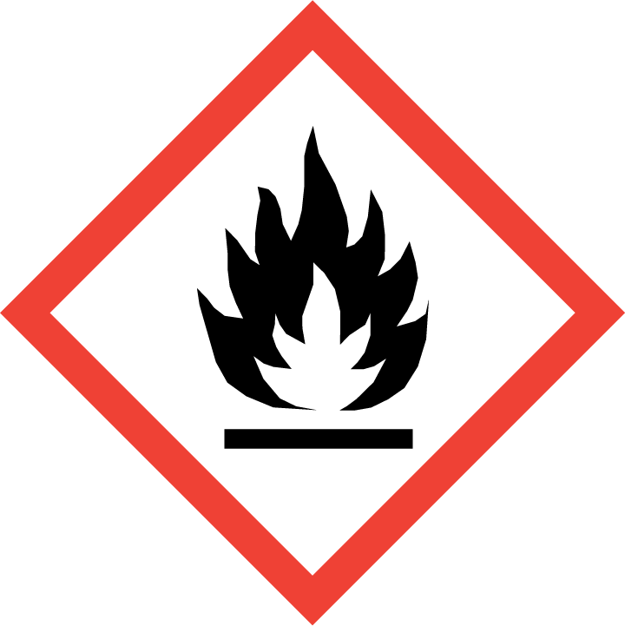 | 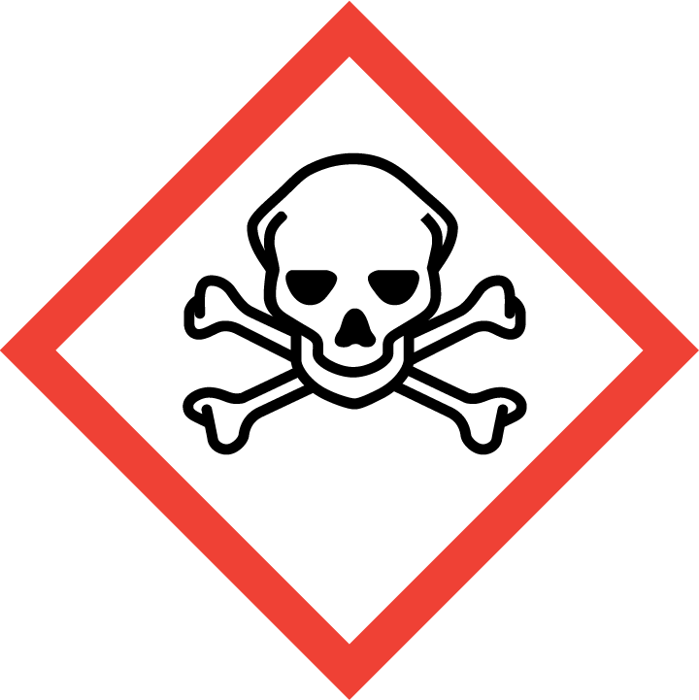 | 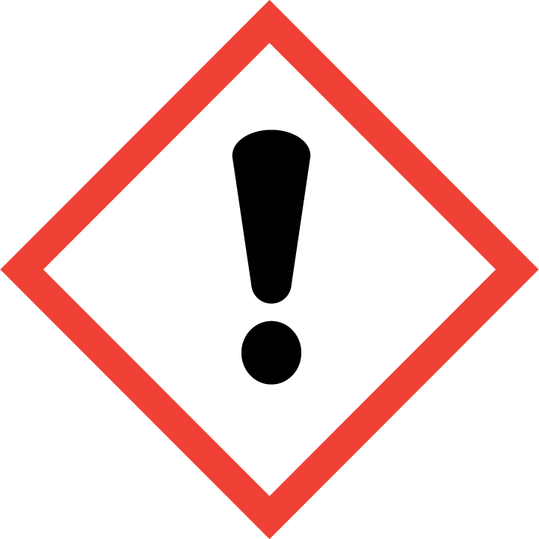 | 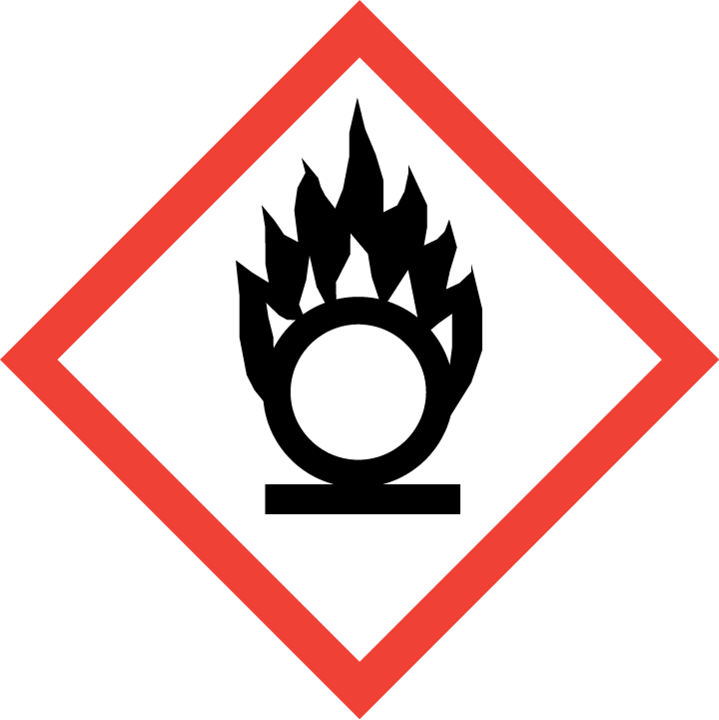 | 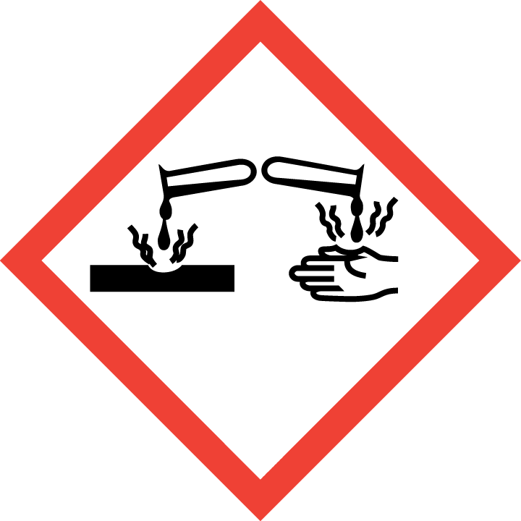 | 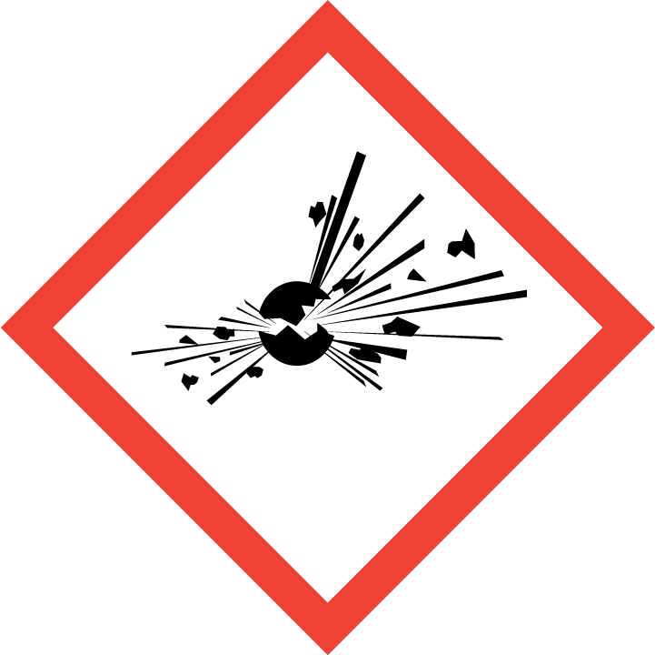 | 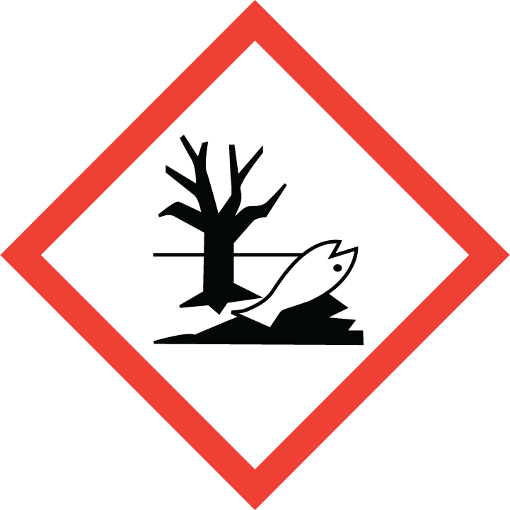 | 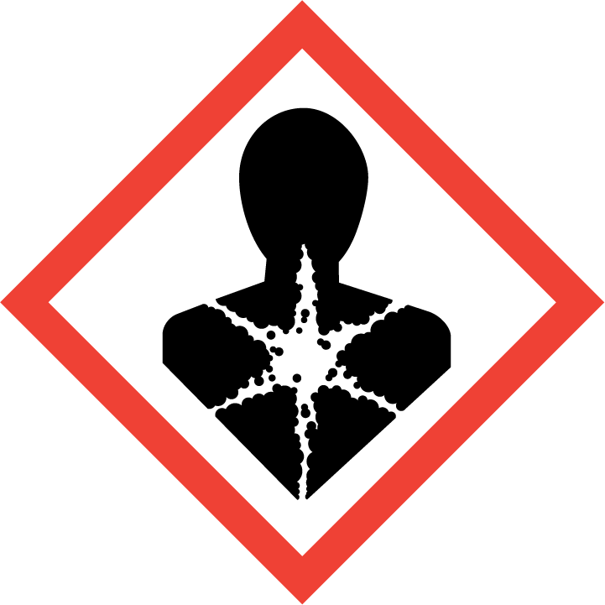
Flammable  Highly flammable | Toxic | Harmful  Irritant | Oxidising | Corrosive | Explosive | Harmful to the environment | Health Hazards i.e. respiratory sensitisation or carcinogenicity
 |  |  |  |  |  | 

SMOKING, EATING AND DRINKING ARE PROHIBITED IN THE WORK AREAS.
Information, Instruction and Training must be provided to all users. Young Persons, New or Expectant Mothers and other vulnerable groups must not use or be exposed to this product.

WORKPLACE EXPOSURE LIMITS (WEL’s)
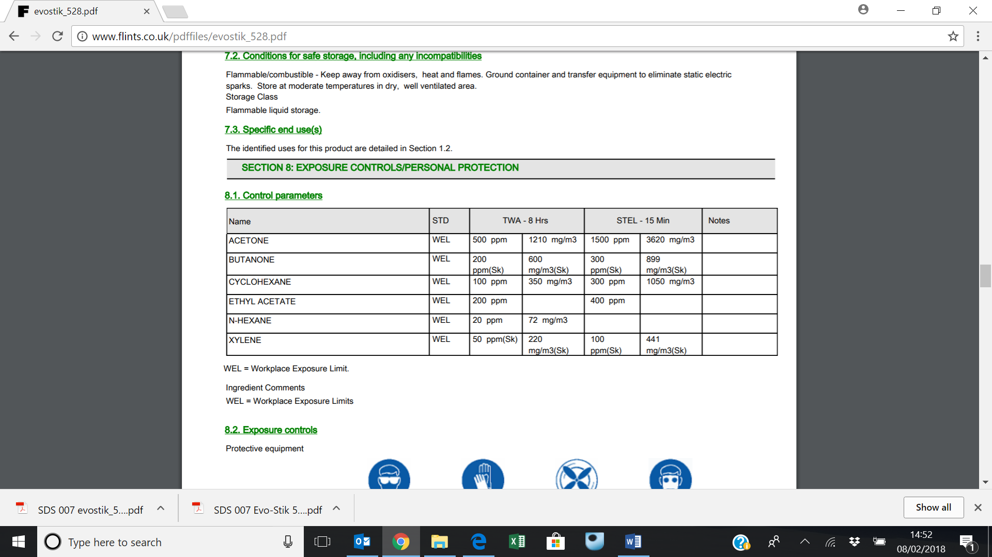
IMPORTANT!
Refer to Workplace Exposure Levels information provided in the Manufacturers Safety Data and revise control measures if exposure levels likely to be reached.

ROUTE OF EXPOSURE
Skin |  | Eyes |  | Inhalation | 
Ingestion |  | Cuts/abrasions |  | Systemic

PERSONS AT RISK
User of product |  | Co workers |  | Members of the public

ROUTE OF EXPOSURE |   FIRST AID MEASURES
Eyes | Eye contact Rinse the eye with water immediately. Continue to rinse for at least 15 minutes and get medical attention
Skin | Promptly wash contaminated skin with soap or mild detergent and water. Promptly remove clothing if soaked through and wash as above. Get medical attention if irritation persists after washing.
Inhalation | Remove victim immediately from source of exposure. Move the exposed person to fresh air at once. Get medical attention. Ingestion
Ingestion | DO NOT induce vomiting. Get medical attention immediately
In all cases of doubt, or if symptoms persist seek medical attention. Never give anything by mouth to an unconscious person. If unconscious, place in recovery position and seek medical advice.

PERSONAL PROTECTIVE EQUIPMENT
 |  |  |  | 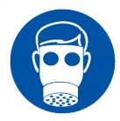 |  | 
YES | YES | YES/NO |  | YES/NO | YES | YES/NO
 |  |  |  |  | 
Wear splash-proof eye goggles to prevent any possibility of eye contact. | Wear appropriate clothing to prevent repeated or prolonged skin contact. |  | LEV or facemask to be worn with filter for organic substances if air contamination exceeds acceptable level |  | Protective gloves must be used if there is a risk of direct contact or splash. Use protective gloves made of: Nitrile.

HANDLING | STORAGE | TRANSPORT | DISPOSAL
Keep away from heat, sparks and open flame. Avoid spilling, skin and eye contact. Ventilate well, avoid breathing vapours. Use approved respirator if air contamination is above accepted level. | Flammable/combustible - Keep away from oxidisers, heat and flames. Ground container and transfer equipment to eliminate static electric sparks. Store at moderate temperatures in dry, well- ventilated area. | Class 3 flammable liquids | Classed as hazardous waste. Disposal to licensed waste disposal site in accordance with the local Waste Disposal Authority.

REQUIRED CONTROL MEASURES
- Users to avoid contact with skin and eyes, and inhalation of vapours/ spray or mist arising from the application of this preparation – Use PPE.
- Ensure adequate welfare and washing facilities available and provide users with barrier and restorative creams. Take good hygiene measures.
- Ensure operatives are made aware of and understand the purpose of this assessment and SDS, plus any health implications of using the product.
- Ensure COSHH assessments with accompanying SDS are made available for all employees and users and for inspection and emergency purpose.
- Wash promptly if skin becomes contaminated. Wash hands at the end of each work shift and before eating, smoking and using the toilet.

FIRE PRECAUTIONS
Extinguishing media Fire can be extinguished using: Foam, carbon dioxide or dry powder

Special hazards arising from the substance or mixture
Unusual Fire & Explosion Hazards May travel considerable distance to source of ignition and flash back. Heat may cause the containers to explode. Solvent vapours may form explosive mixtures with air. Vapours are heavier than air and may spread near ground to sources of ignition.

Specific hazards
Toxic gases/vapours/fumes of: Carbon dioxide (CO2). Carbon monoxide (CO).

ACCIDENTAL RELEASE/SPILLAGE PROCEDURES
Personal precautions, protective equipment and emergency procedures
In case of inadequate ventilation, use respiratory protection. Use protective gloves, goggles and suitable protective clothing. Avoid inhalation of vapours and contact with skin and eyes. Provide adequate ventilation.

Environmental precautions : Prevent entry into drains.

Methods and material for containment and cleaning up Absorb with sand or other inert absorbent. Containers with collected spillage must be properly labelled with correct contents and hazard symbol.

MONITORING REQUIREMENTS AND HEALTH SURVEILLANCE
Health surveillance is not in place for workers exposed to this product.

